Swanzey Financial & Governance Review
15 years of budgets, votes, and patterns — and where it's heading

Town of Swanzey, Cheshire County, New Hampshire
PublicLogic VAULT · Final Report · June 2026

1. Executive Summary
Across 15 years of official-ballot town meetings, Swanzey's electorate is consistent, legible, and increasingly stressed. Voters will fund operations but will not borrow; they reward saving and tax credits and punish bonds; their support for the operating budget is eroding; and they are actively restructuring how the town governs itself — all while the Town Administrator's office keeps turning over. The town is simultaneously taking on more (a water utility) and losing the executive continuity needed to deliver it.
Headline figures
- $5.75M → $8.94M operating budget, 2011 → 2025 (+55%)
- ≈ 6.7%/yr recent growth (2021–2025)
- 81% → 57% operating-budget voter support, 2011 → 2025
- $47K (0.5%) 2025 default-vs-proposed gap — the lever is gone
- 2024 & 2026 public works facility 3/5 votes — both failed
- 3 town administrators in ~2 years
The recommendation in one line
Stabilize the administrator, abandon bond-first capital for the reserve/state-aid/SRF strategy the electorate already rewards, and tell voters the truth about revaluation and the budget — in that order.

2. Findings
Provenance: [R-AR] Town of Swanzey Annual Reports 2011–2025; [R-news] local news (2026); [D] derived; [M] modeled.
Finding 1 — Operating budget has entered a high-growth regime
After a flat early-2010s (~+1%/yr), the budget shifted to +6–7%/yr (2020–2025), rising 55% to $8.94M, driven by wages, health insurance, and the ambulance contract.
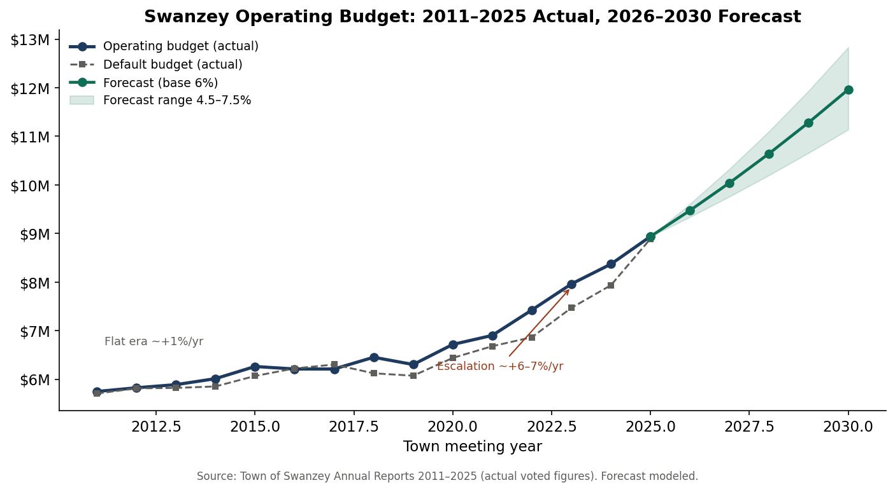
Finding 2 — The default-budget lever has effectively disappeared
The proposed-vs-default gap collapsed from $560K (2022) to $47K (2025); in 2016–2017 the default exceeded the proposal. 'Vote no to save money' no longer works.
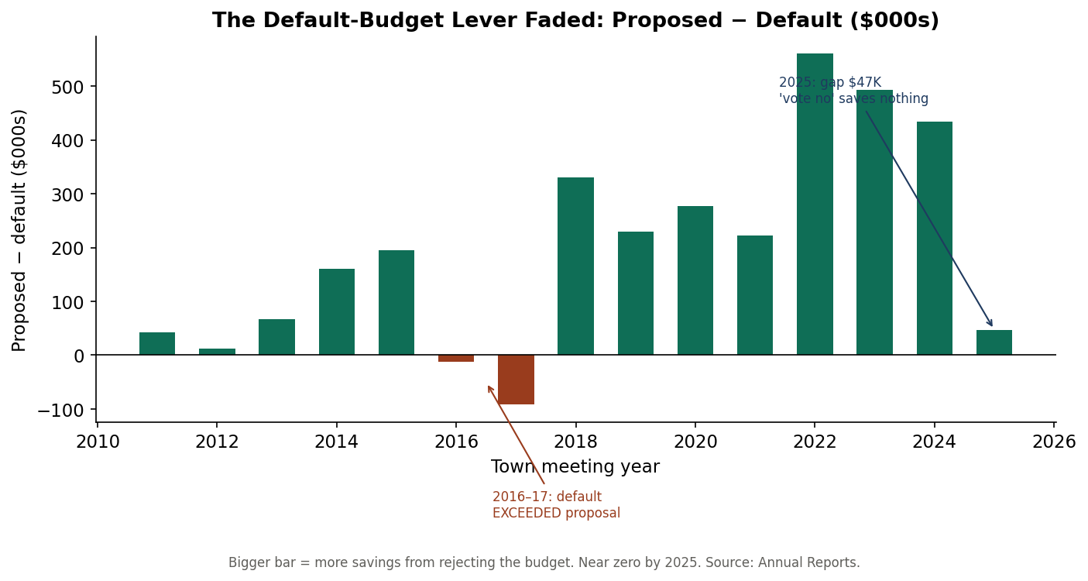
Finding 3 — Operating-budget support is eroding toward the 50% cliff
Approval fell from ~80% (2011–2015) to 57% (2025). A budget failure becomes plausible within a few cycles, though its fiscal impact would now be muted (Finding 2).
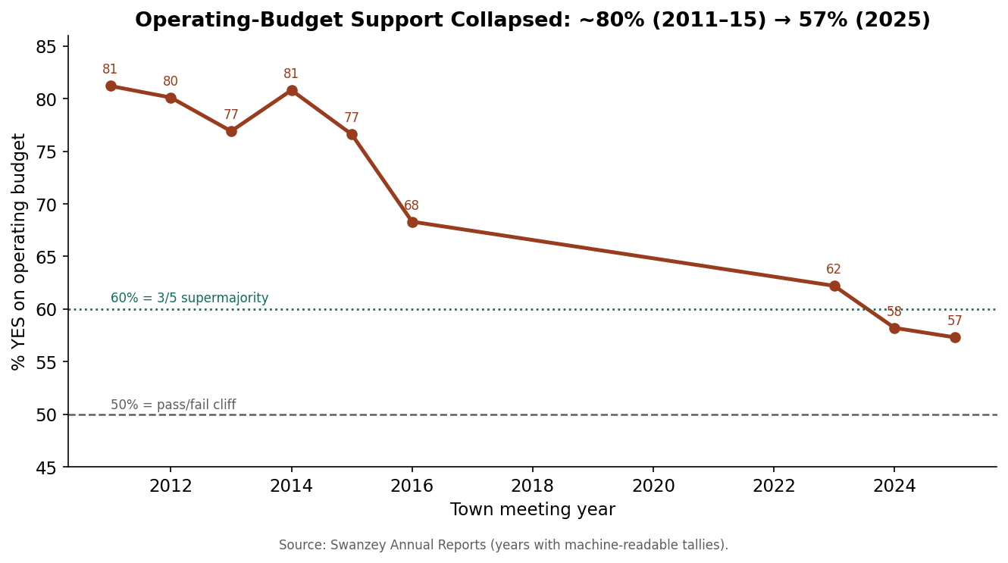
Finding 4 — Capital paralysis at the 3/5 wall
Tax credits pass ~90% and reserves ~78%, but facility bonds get only 55–58% — never the 3/5 a bond needs. The public works facility failed at 3/5 in 2024 and 2026. A threshold problem, not an opposition problem.
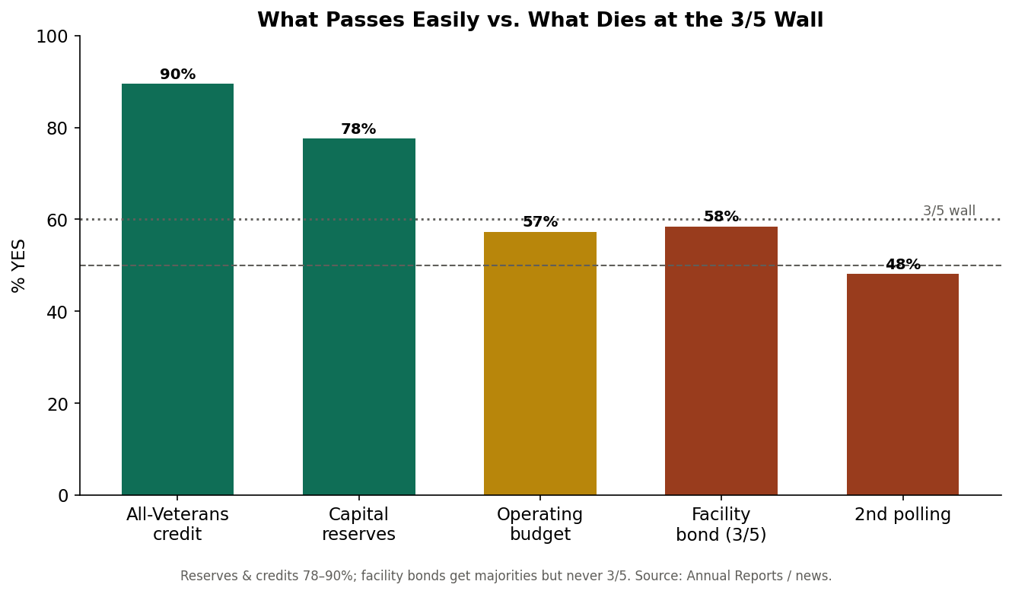
Finding 5 — The 2024 rate decline was a revaluation, not a tax cut
Total rate moved $26.87 (2023) → $19.06 (2024) → $20.18 (2025); the 2024 drop reflects higher assessed values, not lower bills. Education is ~60% of the bill.
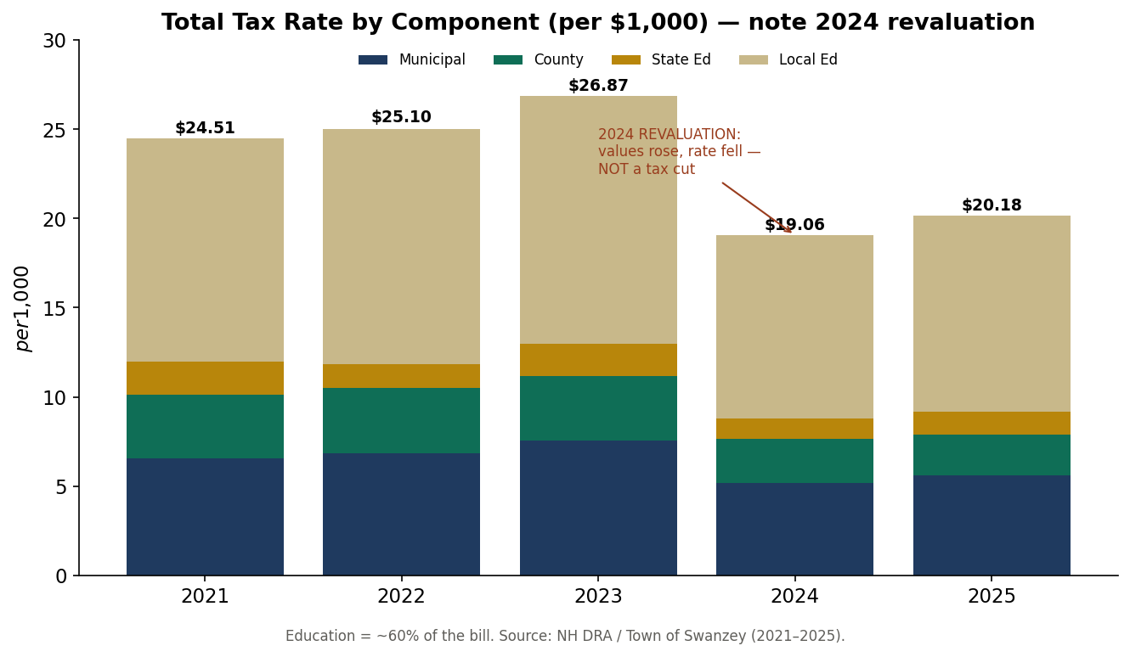
Finding 6 — Governance is being actively restructured
Voters expanded the Select Board 3→5 (2025, 740–653), rejected a second polling location (673–727), and kept SB2 (rejected repeal 345–809 in 2026) — overruling a board that had recommended repeal.
Finding 7 — Administrative instability is the master pain
Three administrators in ~2 years (Branley → Torpey interim → Rautiola → open). Every other initiative restarts with each turnover.
Finding 8 — Development and land use are a live legal exposure
The Avanru 74-unit senior-housing project drew a federal lawsuit alleging boards relied on opposition rather than zoning criteria; the Base Hill Road storage facility has been a multi-year dispute.
Finding 9 — The town is absorbing a water utility
In 2025 voters authorized acquiring the West Swanzey water system (RSA 38:4), created a TIF district, appropriated $3.5M and $6.4M, and funded a study expecting '100% principal forgiveness' (NHDES DWSRF).
Finding 10 — Electoral volatility is rising
Crowded fields, sub-30-vote margins, ousted incumbents, and recounts. Continuity is the scarcest resource.

3. Recommendations
Sequenced for impact.
R1 — Stabilize the Town Administrator (first)
Churn is the precondition pain. Offer a multi-year agreement with a written evaluation and a board–administrator delegation policy. (RSA 41)
R2 — Reserve + state-aid + SRF capital
Bonds die at 3/5; reserves and aid pass. Stand up capital reserve funds (majority vote), pursue 80% bridge aid (RSA 234) and DWSRF water financing. (RSA 35)
R3 — Tell the truth on revaluation & the budget
Publish a plain-language tax-bill explainer and a budget-driver brief. (RSA 21-J, 76)
R4 — Publish a six-year CIP annually
Convert surprise capital into expected line items. (RSA 674:5–8)
R5 — Govern the new five-member board
Adopt operating norms and onboarding. (RSA 41:8, 91-A, 31:39-a)
R6 — Run water as an enterprise
Rate study + asset-management plan; DWSRF repaid by rates. (RSA 38)
R7 — De-risk land-use decisions
Decide strictly on written criteria, with counsel. (RSA 672–677)
Sequencing
R1 is the keystone. R2 and R4 unlock the capital backlog the electorate keeps blocking. R3 rebuilds the trust R2's votes require. R5–R7 protect the institution while the rest takes hold.
Provenance: [R-AR] Town of Swanzey Annual Reports 2011–2025; [R-news] local news (2026); [D] derived; [M] modeled.

